Name:………………………

YORK TO DONCASTER via SELBY (45 miles)
SPONSORED CYCLE RIDE
SATURDAY 24th APRIL 2004

In aid of the York City Supporters Trust

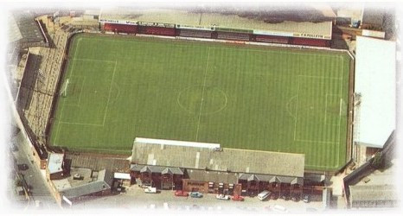

NAME | CONTACT (ADDRESS OR TEL NO) | AMOUNT | PAID

